**Year 8 HASSL**

/52

Task 2 - Mapping & Practical Skills Test

NAME: ___________________ Target: ___/52 or ____ % 👍 👎

**5 minutes reading and 40 minutes working time**

1. List the names of **three types of maps.**  (3)
2. __________________________________________________________
3. __________________________________________________________
4. __________________________________________________________
5. State what **BOLTSS** stands for. (6)

B - ________________________________

O - ________________________________

L - ________________________________

T - ________________________________

S - ________________________________

S - ________________________________

1. For each of the following scales, calculate how many kilometres are represented by one centimetre on the map. (3)
   1. 1:250 000 = _________________ km’s
   2. One centimetre to 50,000 cm’s = __________________km’s
   3. Write 1:100,000 as a statement of scale. ______________________________________________________________________________________________________________________________________
2. State THREE ways that scale can be shown on a map: (3)

|  |  |
| --- | --- |
| i) | iii) |
| ii) |  |

1. Outline one reason why a person may use a map. (2)

________________________________________________________________________________________________________________________________________________________________________________________________________________________________________________________________________________________________________________

1. Label the compass rose. (7)

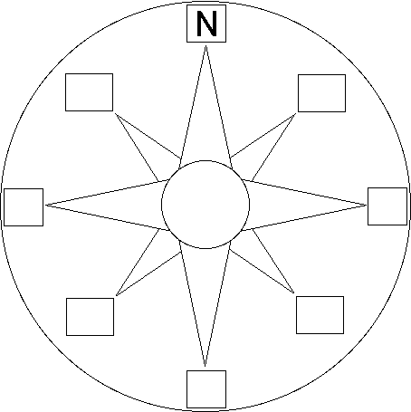

7. List the intermediate cardinal points: (4)

* ______________________
* ______________________
* ______________________
* ______________________

8. Label on the grid which lines are northings and which are eastings. (2)

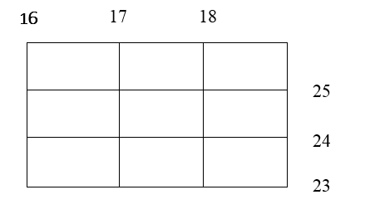

9. How many numbers does an area reference have? _____________ (1)

1. How many numbers does a grid reference have? ______________ (1)
2. Do eastings or northings go first when writing out the co-ordinates? (1) ________________________________

|  |  |  |  |  |  |  |  |  |  |  |  |  |  |  |  |  |
| --- | --- | --- | --- | --- | --- | --- | --- | --- | --- | --- | --- | --- | --- | --- | --- | --- |
| 24 | |  | | | | | | | | | | | | | |  |
| 23 | | ◼◼  ◼  ◼◼  ◼◼◆ | |  | |  | |  | | http://upload.wikimedia.org/wikipedia/commons/b/bc/NPS_map_symbol_bridge.png | | ◼◼  ◼ | | ◼ ◆  ◆ ◼  ◼ ◼  ◼◼◼ | |  |
| 22 | | ◼◼◼◼  ◼◼  ◼ | | ◼◼◼◼  ◆ ◼◼  ◆ ◼  ◼ ◼ ◆ | |  | | ****  **** | | ✆  **** | |  | |  | |  |
| 21 | | ϔ  ϔ | | ϔ  ϔ | |  | | **** | | 🖂  **** | |  | |  | |  |
| 20 | | ◼ ◼ | | ◼ | |  | | ****  ϔ | |  | | http://upload.wikimedia.org/wikipedia/commons/b/bc/NPS_map_symbol_bridge.png | | N | |  |
| 19 | |  | | ◼  ◼ | |  | | ϔ  ϔ  ϔ | | ϔ | |  | |  | |  |
|  | 07 | | 08 | | 09 | | 10 | | 11 | | 12 | | 13 | | 14 | |

1. Use the map to answer the questions below:

|  |  |  |  |  |  |  |  |  |  |
| --- | --- | --- | --- | --- | --- | --- | --- | --- | --- |
| **LEGEND** | | | | | | | | | |
| ◼◼ | Houses | **** | Office |  | Courthouse | ✆ | Phone booth | ϔ | Palm tree |
|  | Church |  | School |  | Car park |  | Hospital |  | Café |
| 🖂 | Post office |  | Bridge |  | Road |  | River |  | Farm land |

1. What do the following symbols represent: (3)

* ________________



* ________________



* ________________



1. Write the area reference for the following: (3)

* Hospital ___________________
* Post Office _________________
* Church_____________________

1. Describe what feature is located at each of the following area references: (3)

* AR1020 _____________________
* AR0722 _____________________
* AR0919 _____________________

1. In what direction is the phone booth from the hospital? (1)

___________________________________________

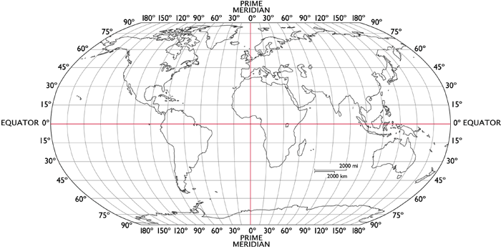

1. Which line of **latitude** divides the world into the northern and southern hemisphere? (1)

_________________________________________________________________

1. What **two** hemispheres does the Prime Meridian divide the world into? (2)

__________________________ ___________________________

1. At what **degrees** is the Prime Meridian? (1)

______________________________

1. Name the continent at (30oS,60oW)? (1)

______________________________

1. What is the name of the continent that **all** lines of **longitude** pass through? (1)

_______________________________

1. List three things shown on a topographic map (3)

_______________________________________

_______________________________________

_______________________________________

**END OF TEST**